YOLO11 Image Classification - Documentation
This project trains a YOLO11 image classification model for vehicle type classification. The results documented here are taken from the current local run artifacts in runs/classify/train/, especially results.csv and args.yaml.

What This Model Does
The model predicts one class for each full image:
Class | Train images | Valid images | Test images
Pick-Up | 1,236 | 82 | 88
SUV | 1,341 | 93 | 104
VAN | 1,236 | 98 | 81
Total | 3,813 | 273 | 273

Project Layout
2. Classification/
|-- check_dataset.py
|-- dataset/
| |-- train/Pick-Up/, train/SUV/, train/VAN/
| |-- valid/Pick-Up/, valid/SUV/, valid/VAN/
| `-- test/Pick-Up/, test/SUV/, test/VAN/
|-- predict.py
|-- README.md
|-- runs/classify/
| |-- predict/
| |-- train/
| | |-- args.yaml
| | |-- results.csv
| | |-- results.png
| | |-- confusion_matrix.png
| | |-- confusion_matrix_normalized.png
| | |-- train_batch*.jpg and val_batch*_*.jpg
| | `-- weights/best.pt and weights/last.pt
| `-- val/
|-- train.py
`-- yolo11n-cls.pt
Note: dataset/, runs/, .venv/, and *.pt files are ignored by git in this folder. The documentation references local artifacts that exist on this machine. If this project is shared, export the run artifacts separately.

Dataset Summary
Classification uses folder names as labels. There is no data.yaml and no label text file per image.
Expected layout:
dataset/
|-- train/
| |-- Pick-Up/
| |-- SUV/
| `-- VAN/
|-- valid/
| |-- Pick-Up/
| |-- SUV/
| `-- VAN/
`-- test/
|-- Pick-Up/
|-- SUV/
`-- VAN/
Split totals:
Split | Total images | Classes present
Train | 3,813 | Pick-Up, SUV, VAN
Valid | 273 | Pick-Up, SUV, VAN
Test | 273 | Pick-Up, SUV, VAN
The split structure is consistent: all three classes exist in train, valid, and test.

Environment
This folder uses its own Python virtual environment:
cd "2. Classification"
.\.venv\Scripts\python.exe -c "import torch; print(torch.cuda.is_available())"
Expected GPU result: True when CUDA-enabled PyTorch is installed. CPU training also works but is slower.

Training Configuration
The current run was launched by train.py and saved to runs/classify/train/. The full resolved configuration is saved in runs/classify/train/args.yaml.
Setting | Value
Task | Classification
Base model | yolo11n-cls.pt
Data folder | dataset/
Configured epochs | 100
Completed epochs in log | 66
Image size | 224
Batch size | 32
Early stopping patience | 25
Device | 0 GPU
Optimizer | auto
AMP | true
Seed | 0
Output folder | runs/classify/train/
Run training:
cd "2. Classification"
.\.venv\Scripts\python.exe train.py
train.py validates the dataset first by calling check_dataset.py. If blocking errors are found, training stops before any GPU time is spent.

Training Results
Primary metric: accuracy_top1. This is the percentage of validation images where the model’s top prediction is correct.
Metric | Best epoch 41 | Final epoch 66
Top-1 accuracy | 0.9927 | 0.9853
Top-5 accuracy | 1.0000 | 1.0000
Train loss | 0.0505 | 0.0271
Validation loss | 0.0400 | 0.0381
Top-5 accuracy is not very useful for this project because there are only three classes. The main score to report is top-1 accuracy.
The best checkpoint is:
runs/classify/train/weights/best.pt
Use best.pt for inference unless you specifically need the final checkpoint last.pt. Both checkpoint files are about 3.04 MB.

Result Figures
Training curves:
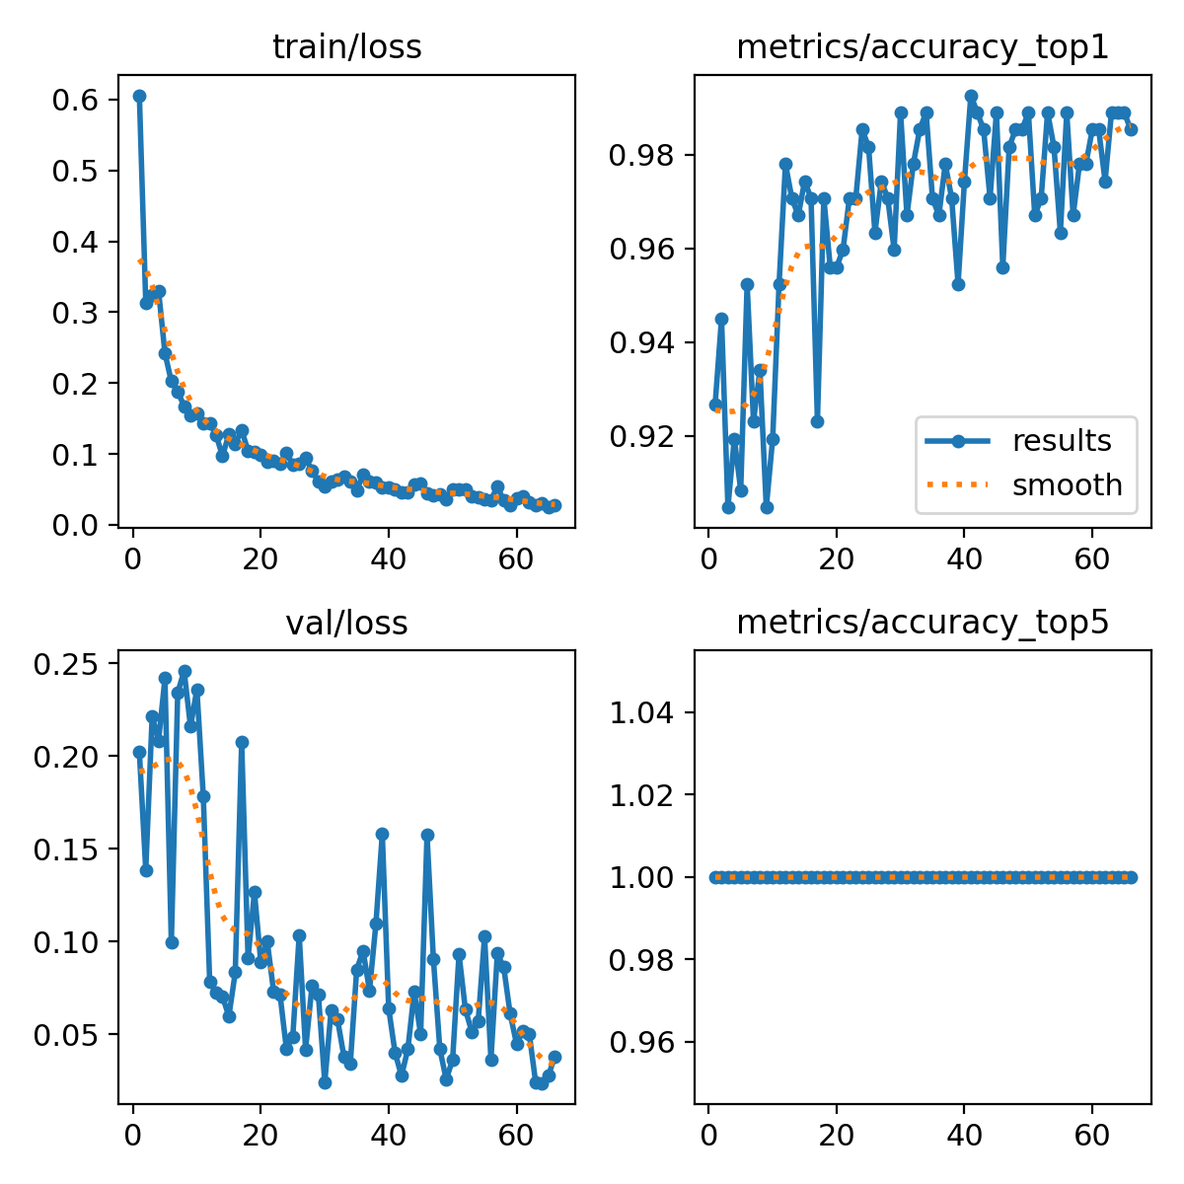
Training results
Confusion matrix:
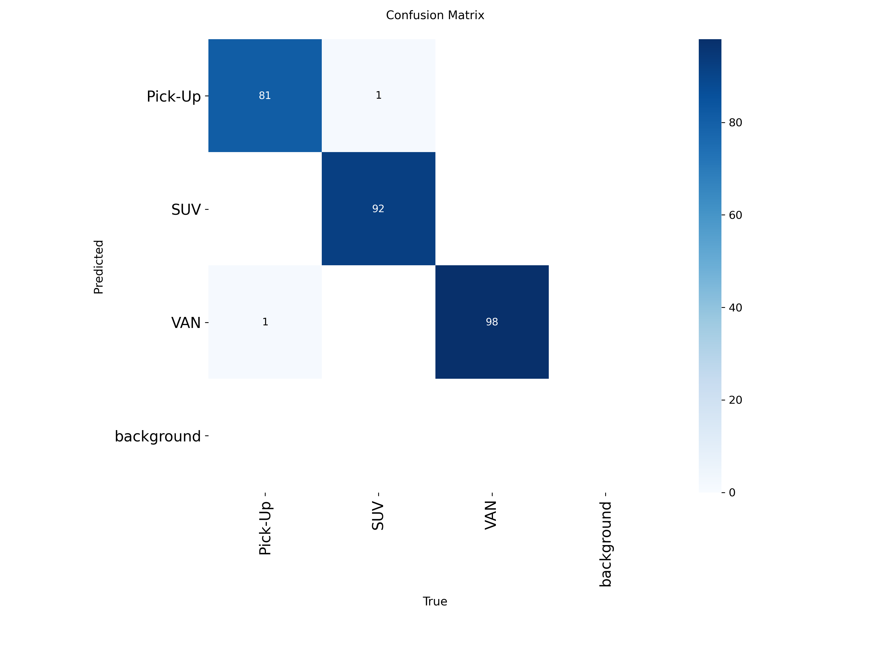
Confusion matrix
Normalized confusion matrix:
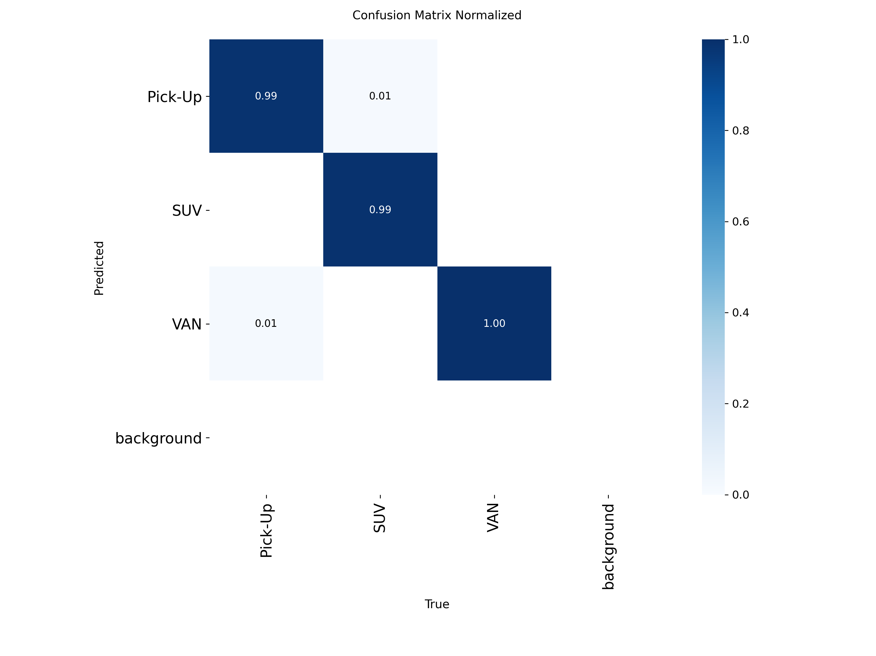
Normalized confusion matrix
Additional training artifacts:
File | Meaning
results.csv | Per-epoch losses, top-1 accuracy, top-5 accuracy, and learning rates
results.png | Visual summary of training and validation curves
confusion_matrix.png | Raw validation confusion matrix
confusion_matrix_normalized.png | Normalized validation confusion matrix
train_batch*.jpg | Augmented training batch samples
val_batch*_labels.jpg | Validation images with ground-truth labels
val_batch*_pred.jpg | Validation images with predicted labels
weights/best.pt | Best checkpoint selected from validation performance
weights/last.pt | Final checkpoint from the last logged epoch

Validation Run Artifacts
runs/classify/val/ exists and contains a validation artifact set generated from model validation:
Artifact type | Files
Confusion matrices | confusion_matrix.png, confusion_matrix_normalized.png
Validation examples | val_batch0_*, val_batch1_*, val_batch2_*
Use the train/ folder for the logged training history. Use the val/ folder to inspect a separate validation visualization pass.

Inference
The inference script uses:
Setting | Value
Weights | runs/classify/train/weights/best.pt
Source | dataset/test/ recursively
Image size | 224
Output folder | runs/classify/predict/
Run prediction:
cd "2. Classification"
.\.venv\Scripts\python.exe predict.py
The current local prediction folder contains 273 annotated image files, matching the number of images in the test split.
For each image, predict.py prints:
image_name.jpg -> predicted_class (confidence)

How To Read The Metrics
Metric | Meaning
Top-1 accuracy | The model’s highest-confidence class equals the true class
Top-5 accuracy | The true class is within the model’s top 5 classes; not meaningful here because there are only 3 classes
Train loss | Optimization loss on training batches; lower is better
Validation loss | Loss on validation data; lower is better
For this project, report accuracy_top1 = 0.9927 from epoch 41 as the best validation result.

Dataset Validation
Run the checker directly:
cd "2. Classification"
.\.venv\Scripts\python.exe check_dataset.py
The checker verifies:
- dataset/ exists.
- train, valid, and test splits exist.
- Each split contains class subfolders.
- Every class folder contains image files.
- Class names are consistent across all splits.

Troubleshooting
Problem | Fix
CUDA out of memory | Lower BATCH from 32 to 16 or 8 in train.py.
Dataset validation fails | Make sure each split contains Pick-Up, SUV, and VAN folders.
Model predicts one class too often | Inspect the confusion matrix and check class balance or image leakage.
Prediction finds no images | Confirm SOURCE = dataset/test in predict.py and test images are inside class subfolders.
Top-5 looks perfect | Ignore top-5 for reporting; use top-1 because this is a 3-class problem.

Reproducible Workflow
cd "2. Classification"
.\.venv\Scripts\python.exe check_dataset.py
.\.venv\Scripts\python.exe train.py
.\.venv\Scripts\python.exe predict.py
Report the model using the best-validation result: accuracy_top1 = 0.9927 at epoch 41.

